## Configuring Dependency Injection in Angular

So far in this section we’ve only covered how to use the low level Dependency Injection API.

With Angular however we’ll never need to create injectors ourselves, Angular does this for us automatically when our application is bootstrapped.

All we need to do is to *configure* Angular with our providers and also tell it when we want something *injected* into a class constructor.

**Learning Objectives**

* What is the injector tree and how it maps to the component tree.
* How an where to configure injectors.
* Know when to use the @Inject and @Injectable decorators.
* Know when we *don’t* need to use the @Inject and @Injectable decorators.

**The Injector Tree**

An Angular application will have a tree of injectors mirroring the component tree.

We have a top level parent injector which is attached to our NgModule.

Then we have *child* injectors descending in a hierarchy matching the component tree.

So a *parent* component will have a child injector stemming from NgModule.

A *child* component of parent component will have a child injector stemming from *Parent*.

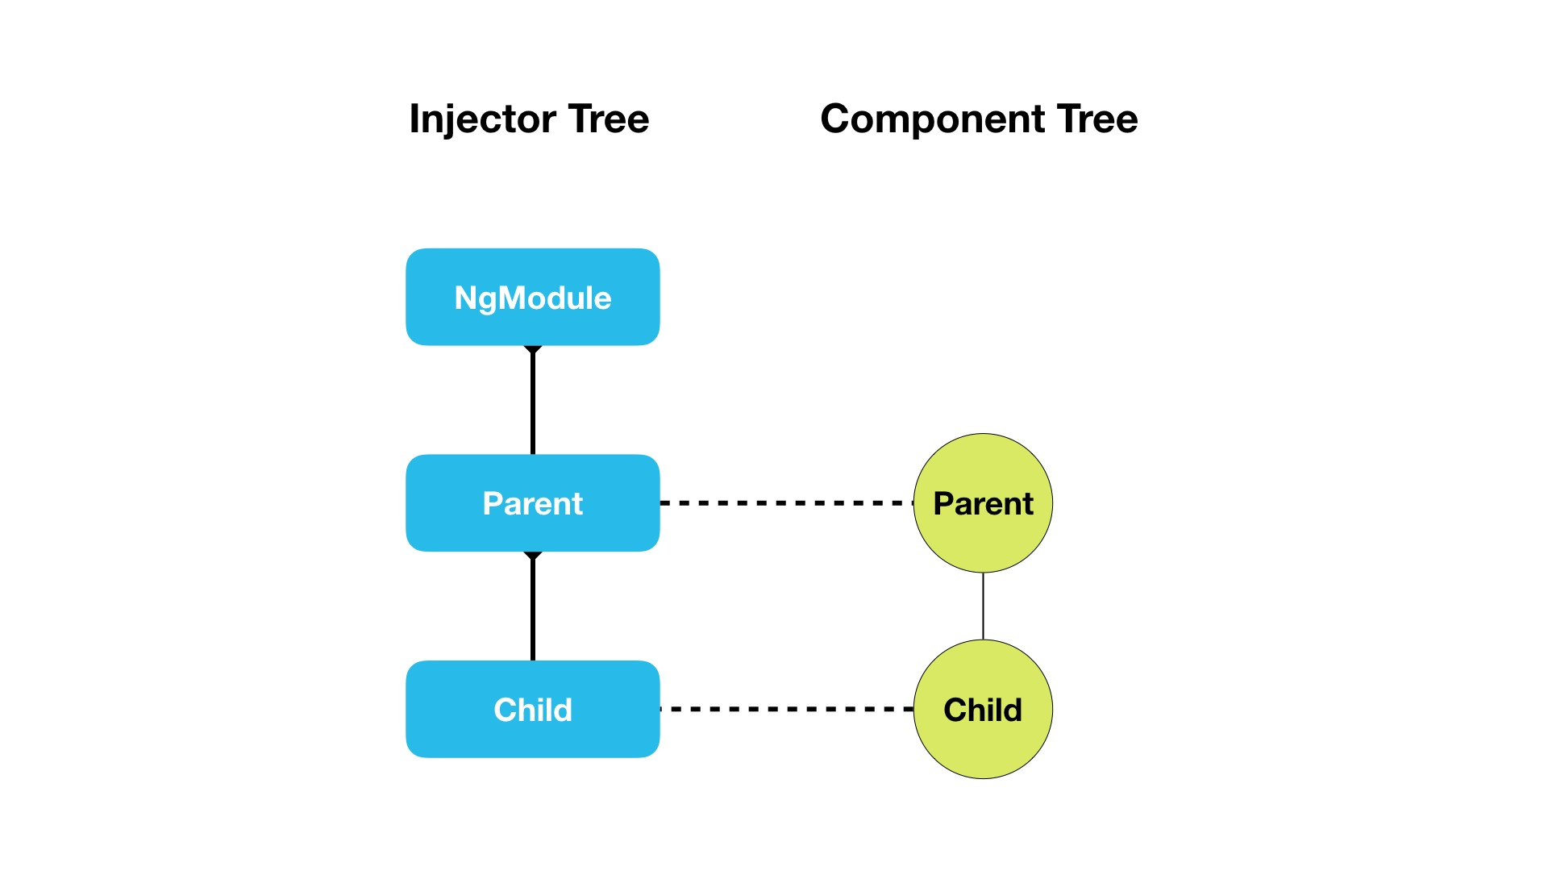

### Configuring Injectors

The NgModule decorator has a property called providers which accepts a list of providers exactly the same as we would pass to the ReflectiveInjector via the resolveAndCreate function we looked at previously, like so:

@NgModule({

providers: [EmailService, JobService]

})

class AppModule { }

This creates a top level *parent* injector and configures it with two class providers, EmailService and JobService.

We can also configure our *Components* and *Directives* the same way using a property called providers on the Component and Directive decorators, like so:

@Component({

selector: 'my-comp',

template: `...`,

providers: [EmailService]

})

This creates a *child injector* who’s parent injector is the injector on the parent component. If there is no parent component then the parent injector is the top level NgModule injector.

With components we have another property called viewProviders which creates a special injector that resolves dependencies only for *this* components view children and doesn’t act as a parent

injector for any content children, like so:

@Component({

selector: 'my-comp',

template: `...`,

viewProviders: [EmailService]

})



We’ll be going through a specific examples of each in the next lecture.

**Using Dependency Injection in Angular**

The above is how we *configure* DI in Angular so it creates injectors and configures them to resolve dependencies.

When Angular creates a component it uses the DI framework to figure out *what* to pass to the component class constructor as parameters.

However we may need to give Angular some hints by using either the @Inject or @Injectable decorators.

Let’s explain with an example, we have a class called SimpleService and another class called OtherService.

class OtherService {

constructor() { };

}

class SimpleService {

constructor() { };

}

We configure NgModule with these classes as providers.

@NgModule({

...

providers: [OtherService, SimpleService]

})

export class AppModule {

}

Then to make Angular resolve and create a SimpleService we add a component which requests an instance of SimpleService via it’s constructor, like so:

@Component({

selector: 'simple',

template: `<p>Simple is as simple does</p>`,

})

class SimpleComponent {

constructor(private simpleService:SimpleService) { }

}

### @Inject decorator

The above works fine but, lets try and inject into SimpleService an instance of OtherService, like so:

class SimpleService {

otherService: OtherService;

constructor(otherService: OtherService) {

this.otherService = otherService;

};

}

This doesn’t work and in fact gives us the error:

Can't resolve all parameters for SimpleService: (?).

We need to *explicitly* tell Angular *what* we want injected for the otherService parameter so we use the @Inject decorator like so:

import { Inject } from '@angular/core';

.

.

.

class SimpleService {

otherService: OtherService;

constructor(@Inject(OtherService) otherService: OtherService) {

this.otherService = otherService;

};

}

The first param to @Inject is the token we want to resolve this dependency with.

The above now works, when Angular tries to construct the class it gets the instance of OtherService passed in from the DI framework.

### @Injectable decorator

Decorating all our constructor arguments with @Inject can be tiresome however so instead we can decorate our *entire* class wth @Injectable, like so:

@Injectable()

class SimpleService {

otherService: OtherService;

constructor(otherService: OtherService) {

this.otherService = otherService;

};

}

I find the term @Injectable confusing, it implies that you need to decorate a class with @Injectable to *inject* it into other classes.

@Injectable is actually a shortcut for having to decorate every parameter in your constructor with @Inject.

It does this for you behind the scenes by looking at the *types of each parameter*, so if we *don’t* supply a type @Injectable *doesn’t* work, like so:

@Injectable()

class SimpleService {

otherSimple: OtherSimpleService;

constructor(otherSimple: any) {

①

this.otherSimple = otherSimple;

};

}

① We don’t provide a type for otherService so the DI framework doesn’t know what to inject and therefore Can’t resolve all parameters for SimpleService: (?). is printed to the console.

Personally I believe @Injectable should be renamed @AutoInject to reduce confusion.

### @Injectable versus @Component versus @Directive

You might ask then why did we not use the @Injectable decorator on the component we inject SimpleService into, like so:

@Component({

selector: 'simple',

templateUrl: `<p>Simple is as simple does</p>`,

})

class SimpleComponent {

constructor(private simpleService:SimpleService) { }

}

That’s because the other decorators in Angular, such as @Component and @Directive, already perform the same function as @Injectable.

We *only* need to use @Injectable on classes which don’t already use one of the other Angular decorators.

**Summary**

There is one top level injector created for each NgModule and then for each component in our app, from the root component down, there is a tree of injectors created which map to the component tree.

We configure these injectors with providers by adding the configuration to either the providers property on the NgModule, Component and Directive decorators or to the viewProviders property on the Component decorator.

We use the @Inject parameter decorator to instruct Angular we want to resolve a token and inject a dependency into a constructor.

We use the @Injectable class decorators to automatically resolve and inject all the parameters of class constructor.

This only works if each parameter has a TypeScript type associated with it, which the DI framework uses as the token.

We don’t need to use the @Injectable class decorator on classes which are already decorated with one of the other Angular decorators, such as @Component.

Now we know *where* we can configure providers in the DI framework in Angular.

In the next lecture we will cover the differences between configuring providers on NgModule, Component.providers and Component.viewProviders.

**Listing**

*script.ts*

import {NgModule, Component, Injectable, Inject, TypeDecorator} from '@angular/core';

import {BrowserModule} from '@angular/platform-browser';

import {platformBrowserDynamic} from '@angular/platform-browser-dynamic';

class OtherService {

constructor() {

};

}

// This version doesn't work as Angular doesn't know it should be injecting

otherService

// class SimpleService {

// otherService: OtherService;

// constructor(otherService: OtherService) {

// this.otherService = otherService;

// };

// }

// This version works but we have to decorate every parameter to our constructor with

@Inject

// class SimpleService {

// otherService: OtherService;

//

// constructor(@Inject(OtherService) otherService: OtherService) {

// this.otherService = otherService;

// };

//

// }

// This works because @Injectable automatically injects every parameter to the

constructor as long as that parameter has a type

@Injectable()

class SimpleService {

otherService: OtherService;

constructor(otherService: OtherService) {

this.otherService = otherService;

};

}

// This DOESN'T work because the otherService parameter doesn't have a type

// @Injectable

// class SimpleService {

// otherService: OtherService;

//

// constructor(otherService: any) {

// this.otherService = otherService;

// };

// }

@Component({

selector: 'simple',

template: `<p>Simple is as simple does</p>`,

})

class SimpleComponent {

constructor(private simpleService: SimpleService) {

}

}

@Component({

selector: 'app',

template: '<simple></simple>'

})

class AppComponent {

}

@NgModule({

imports: [BrowserModule],

declarations: [AppComponent, SimpleComponent],

bootstrap: [AppComponent],

providers: [OtherService, SimpleService]

})

class AppModule {

}

platformBrowserDynamic().bootstrapModule(AppModule);